Copulas: GBPUSD and EURGBP
Method 18 / daily log returns / empirical ranks / Gaussian + Clayton / Alpari D1 full available history

Study setup
Logical pair: GBPUSD , EURGBP
Broker symbols: GBPUSD_i , EURGBP_i
Snapshot: 2026-11-03_majors_alpari_D1
Timeframe: D1
Matched return window: 1999-01-06 to 2026-11-02 (UTC bar dates)
Matched return count n: 7199
Dropped unfinished last bar dated 2026-11-03 UTC after a tick-volume check against the prior complete day.
Margins: empirical ranks / (n+1)
Families: Gaussian (rho) and Clayton (theta), fixed before ranking
Complete matched rows (Excel): GBPUSD-EURGBP_Copula_D1.xlsx
Complete matched rows (HTML table): GBPUSD-EURGBP_Copula_D1_data.html

Method carried forward
Copulas separate marginal return shapes from dependence on the unit square. Matched daily log returns of close, ln(close_t / close_t-1), are mapped to pseudo-observations u_i = rank(x_i)/(n+1) and v_i = rank(y_i)/(n+1). A Gaussian copula parameter rho is the Pearson correlation of Phi^{-1}(u) and Phi^{-1}(v). A Clayton copula theta >= 0 is fit by maximum likelihood on (u,v) for lower-tail asymmetry. Quotes are not inverted. Kendall tau implied by each fit and Spearman of (u,v) are stored. Same-sample Pearson r on returns is a side check. This is not causation and not a trading signal.

Results
Gaussian rho: -0.352016
Gaussian Kendall tau: -0.229007
Clayton theta: 0.000000
Clayton Kendall tau: 0.000000
Spearman of (u,v): -0.317786
Pearson r on returns: -0.397845

Conclusion
Over 7199 matched daily rows for GBPUSD and EURGBP, Gaussian copula rho = -0.3520 (Kendall=-0.2290) and Clayton theta = 0.0000 (Kendall=0.0000). Spearman of (u,v) = -0.3178; Pearson r on returns = -0.3978. This is not causation and not a trading signal.

Charts
Daily closes

Daily log returns

Pseudo-observations (u,v)
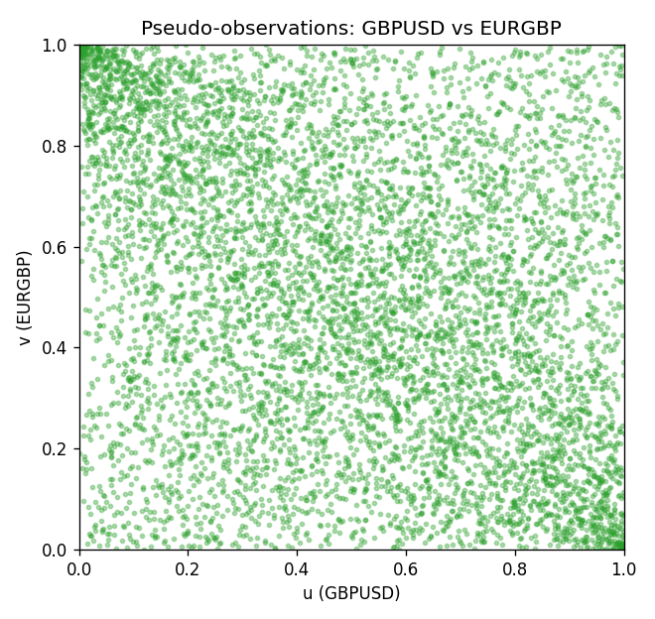

Data report
Every matched row is stored in the sibling Excel workbook named GBPUSD-EURGBP_Copula_D1.xlsx, including u and v. Embedding all rows as a Word table is impractical; this file holds column summaries and the first and last 15 matched rows.
Columns: time, GBPUSD_open, EURGBP_open, GBPUSD_high, EURGBP_high, GBPUSD_low, EURGBP_low, GBPUSD_close, EURGBP_close, GBPUSD_tick_volume, EURGBP_tick_volume, GBPUSD_spread, EURGBP_spread, GBPUSD_real_volume, EURGBP_real_volume, GBPUSD_log_return, EURGBP_log_return, u, v
Column summaries (matched calculation rows)
column | count | mean | std | min | 25% | 50% | 75% | max
GBPUSD_open | 7199 | 1.5160931 | 0.21831499 | 1.06854 | 1.324955 | 1.5114 | 1.63186 | 2.1066
EURGBP_open | 7199 | 0.78665041 | 0.09676322 | 0.5734 | 0.6873 | 0.83367 | 0.865175 | 0.9769
GBPUSD_high | 7199 | 1.5223838 | 0.21887686 | 1.08366 | 1.32978 | 1.5181 | 1.6384 | 2.1161
EURGBP_high | 7199 | 0.78972718 | 0.09713886 | 0.5789 | 0.68935 | 0.83657 | 0.86804 | 0.9799
GBPUSD_low | 7199 | 1.5097628 | 0.21753729 | 1.03518 | 1.3194 | 1.50323 | 1.62442 | 2.0983
EURGBP_low | 7199 | 0.78395066 | 0.09658082 | 0.5682 | 0.6853 | 0.83147 | 0.862765 | 0.9661
GBPUSD_close | 7199 | 1.5161471 | 0.21826306 | 1.06879 | 1.325055 | 1.51122 | 1.63216 | 2.1065
EURGBP_close | 7199 | 0.78669405 | 0.09676312 | 0.5735 | 0.6875 | 0.8337 | 0.86528 | 0.977
GBPUSD_tick_volume | 7199 | 94850.986 | 153561.38 | 62 | 9998.5 | 52911 | 91818.5 | 1273370
EURGBP_tick_volume | 7199 | 86949.029 | 145390.09 | 154 | 6517.5 | 44265 | 81326 | 1424684
GBPUSD_spread | 7199 | 26.96055 | 19.19062 | 0 | 11 | 20 | 50 | 50
EURGBP_spread | 7199 | 21.393666 | 19.14328 | 0 | 4 | 13 | 50 | 50
GBPUSD_real_volume | 7199 | 3.5570778e+09 | 8.4449923e+10 | 0 | 0 | 0 | 0 | 2.4038164e+12
EURGBP_real_volume | 7199 | 2.7805214e+10 | 1.3507095e+11 | 0 | 0 | 0 | 0 | 3.5726265e+12
GBPUSD_log_return | 7199 | -3.133e-05 | 0.00564236 | -0.08388241 | -0.00313644 | 2.978e-05 | 0.00317207 | 0.03112653
EURGBP_log_return | 7199 | 2.179e-05 | 0.00487166 | -0.03067367 | -0.0026225 | -0.00010035 | 0.00256076 | 0.06075387
u | 7199 | 0.5 | 0.28865508 | 0.00013889 | 0.25006944 | 0.5 | 0.74993056 | 0.99986111
v | 7199 | 0.5 | 0.28865504 | 0.00013889 | 0.25006944 | 0.5 | 0.74993056 | 0.99986111
First 15 matched rows (selected columns)
time | GBPUSD_log_return | EURGBP_log_return | u | v
1999-01-06 | -0.00060452184 | -0.013303338 | 0.4425 | 0.0080555556
1999-01-07 | -0.002118709 | 0.011051402 | 0.32166667 | 0.98222222
1999-01-08 | -0.0058954193 | -0.004943862 | 0.11819444 | 0.11930556
1999-01-11 | -0.0056851331 | -0.0012752393 | 0.12513889 | 0.37472222
1999-01-12 | 0.0022657001 | 0.0033970309 | 0.68916667 | 0.80208333
1999-01-13 | 0.0091330396 | 0.00042381861 | 0.95486111 | 0.55041667
1999-01-14 | 0.0019376331 | -0.0019793588 | 0.66236111 | 0.30819444
1999-01-15 | -0.0017558204 | -0.0076715819 | 0.34916667 | 0.048611111
1999-01-18 | 0.0012112405 | 0.00071280921 | 0.60430556 | 0.58069444
1999-01-19 | 0.0018745281 | -0.0014261269 | 0.65652778 | 0.36152778
1999-01-20 | -0.0049053846 | 0.0019960086 | 0.15666667 | 0.70597222
1999-01-21 | 0.0031518998 | -0.00071240297 | 0.74833333 | 0.43208333
1999-01-22 | 0.0024781662 | -0.0017118406 | 0.70444444 | 0.33180556
1999-01-25 | 0.0012066366 | -0.0054402425 | 0.60388889 | 0.10138889
1999-01-26 | 0.00072328374 | -0.00057438255 | 0.56333333 | 0.44902778
Last 15 matched rows (selected columns)
time | GBPUSD_log_return | EURGBP_log_return | u | v
2026-10-13 | 0.0036434319 | 0.00020130374 | 0.77777778 | 0.53083333
2026-10-14 | -0.0049164679 | 0.0011241873 | 0.15611111 | 0.62347222
2026-10-15 | 0.0065976411 | -0.00087557391 | 0.90347222 | 0.41277778
2026-10-16 | 0.0037592051 | -0.0020380844 | 0.78458333 | 0.30305556
2026-10-19 | -0.0017500314 | -0.00056950988 | 0.35027778 | 0.44972222
2026-10-20 | 0.0055923442 | -0.0035906254 | 0.87041667 | 0.18597222
2026-10-21 | 0.0012476328 | -0.00140647 | 0.60708333 | 0.36291667
2026-10-22 | 0.00022396082 | -0.0018743924 | 0.51888889 | 0.31708333
2026-10-23 | -0.0021146949 | 0.00082421033 | 0.32222222 | 0.59263889
2026-10-26 | -0.0024340661 | 0.00013133309 | 0.29763889 | 0.52222222
2026-10-27 | -0.0023648393 | -0.0019957343 | 0.30277778 | 0.30694444
2026-10-28 | 0.0015771808 | 0.00066967224 | 0.63402778 | 0.5775
2026-10-29 | 0.0035881935 | -0.0011722209 | 0.77555556 | 0.38416667
2026-10-30 | 0.0013450605 | -0.0024205543 | 0.615 | 0.26819444
2026-11-02 | 0.0010971256 | 0.00089940465 | 0.59486111 | 0.60097222

